**Assignment 1:**

**Draw your Home Network Topology and explain how you are accessing the RPS Lab environment.**

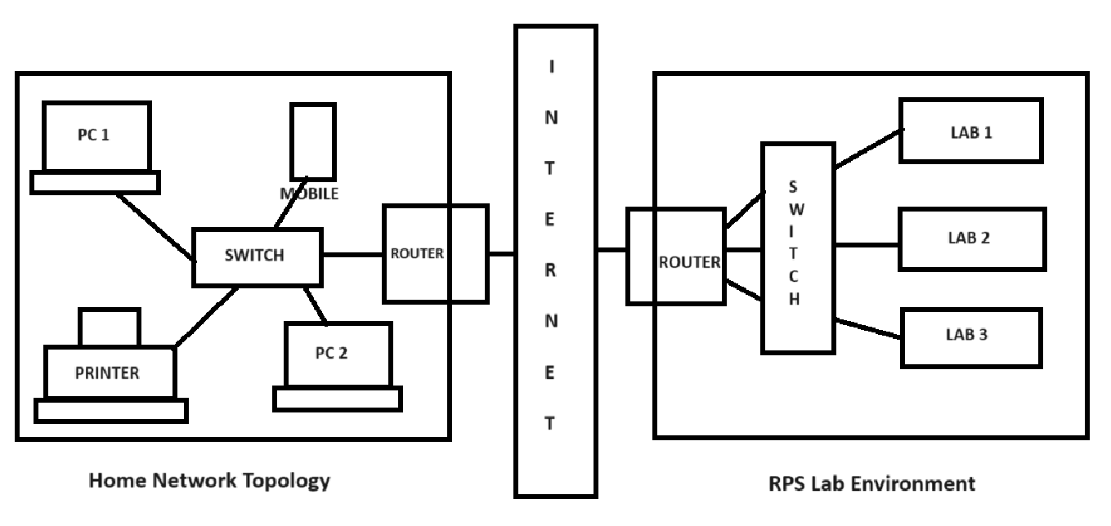

**Assignment 2**:

**Identify a real-world application for both parallel computing and networked systems. Explain how these technologies are used and why they are important in that context.**

A real-world application that utilizes both parallel computing and networked systems is weather forecasting and climate modeling.

In weather forecasting and climate modeling, massive amounts of data need to be processed, analysed, and simulated to predict future weather patterns or understand long-term climate trends. These computational tasks involve complex mathematical models that simulate atmospheric dynamics, ocean currents, land surface interactions, and other environmental factors.

Parallel computing is essential in this context because weather and climate models are highly complex and computationally intensive. By breaking down these models into smaller, parallelizable tasks, researchers can distribute the workload across multiple computing nodes or cores, enabling faster simulations and more detailed forecasts.

Networked systems play a critical role in weather forecasting and climate modeling by facilitating the exchange of data between different computing nodes, research institutions, and observational networks. Real-time data from weather stations, satellites, buoys, and other sensors are continuously collected and transmitted over networks to central computing facilities where they are assimilated into models and used to refine forecasts.

The importance of parallel computing and networked systems in weather forecasting and climate modeling lies in their ability to improve the accuracy and resolution of predictions, which are vital for disaster preparedness, agriculture, energy planning, and other sectors. By harnessing parallel processing and networking technologies, researchers can run more sophisticated models, incorporate more observational data, and provide more timely and reliable forecasts to decision-makers and the public.